Asked pt reason for attendance:
Checked pt happy to go ahead:
(Who is present in the surgery)
Medical history checked:
Social history reviewed:
Pt c/o:
E/o exam TMJ:
Lymph nodes:
Skin check:
Any signs of non-accidental injury:
I/o exam STE:
Charting done:
BPE:
BEWE Toothwear:
Absent teeth evaluated:
Perio risk assessment:
Caries risk assessment:
Smoking/alcohol cessation:
Radiographs: Date of last bws:
Justification:
QA:
Report:
Treatment plan: R&B sheet given:
Given Tx plan and costs:
Discussions:
Recall interval:
BEWE index
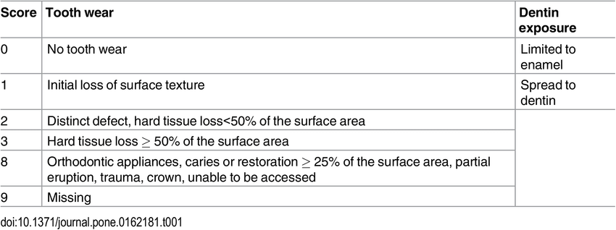

http://www.perio-tools.com/PRA/en/index.asp

Caries Risk Assessment

Date of caries assessment | Date
Age at time of caries assessment | Age
 | yes | no
1. Poor oral hygiene – inefficient, infrequent brushing
2. Sub-optimal fluoride exposure i.e toothpaste and rinses
3. Evidence of poor dietary habits
i.e > 4 sugar intakes/day including food/drinks/meals and snacks
4. Medically compromised, physical disability
5. Evidence of early /cavitated carious lesions
6. Developmental or acquired enamel defects
7. Orthodontic appliances or denture
CARIES RISK ASSESSMENT (Standard risk vs Increased risk/giving concern)
Individuals should be classified into standard risk and ‘those giving concern’ as follows:
Standard caries risk
All age groups | - No early, cavitated primary or secondary carious lesions  - No factors that increase caries risk

Increased risk /Giving concern
Younger than 6 years | - One or two early, cavitated primary or secondary lesions.  - Presence of at least one factor that may increase caries risk  - Those with special needs
Older than 6 years | - One or two early, cavitated primary or secondary lesions  - Presence of at least one factor that may increase caries risk  - Those with special needs  - Those wearing orthodontic appliances
1
Clinical recommendations following caries risk assessment
 | Standard risk | Increased risk/Giving concern
< 3 yrs | - Verify diet  - Reinforce oral hygiene instruction  - Toothpaste containing no less than 1000ppm F-  - May not receive additional benefit from professional topical fluoride | - Verify diet (targeting < four sugary intakes/dy)  - Reinforce oral hygiene instruction  - Toothpaste containing 1350 - 1500ppm F-  - 2.2% NaF varnish three times/yr
3 – 6 yrs | - Verify diet  - Reinforce oral hygiene instruction  - Toothpaste containing more than 1000ppm F-  - 2.2% NaF varnish twice/yr | - Verify diet (targeting < four sugary intakes/dy)  - Reinforce oral hygiene instruction  - Toothpaste containing 1350 - 1500ppm F-  - 2.2% NaF varnish three times/yr
7+ yrs | - Verify diet  - Reinforce oral hygiene instruction  - Toothpaste containing 1350 - 1500ppm Fl  - 2.2% NaF varnish twice/yr | - Verify diet (targeting < four sugary intakes/dy)  - Reinforce oral hygiene instruction  - Toothpaste containing Fluoride  - – 1500ppm for 6-9 year olds  - – 2800ppm for 10-15 year olds  - – 5000ppm for 16+ year olds  - Those > 8 yrs old with active caries prescribe daily 0.05% F- mouthrinse 2.2% NaF varnish three times/yr  - Fissure seal permanent molars
References
- Delivering Better Oral Health. 3rd Edition 2014
- Preventing Dental Caries in Children at High Risk: SIGN publication number 47
- Professionally applied topical fluoride: evidence based clinical recommendations. J Am
Dent Assoc 2006; 137:1151-1159
- Evidence-Based Dentistry (2006) 7,62-64.doi:10.1038/sj.ebd.6400422l

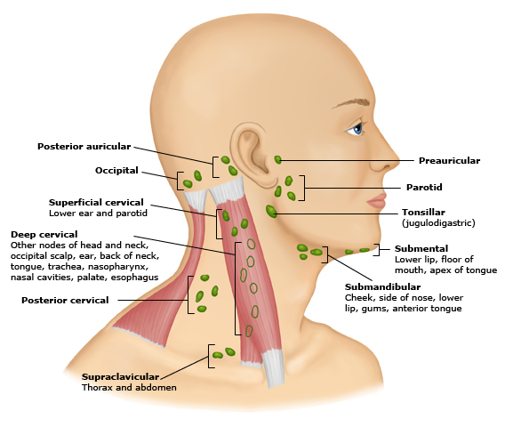

Please tell us a bit about your social history so we can best guide or advise you
Question | Answer | Comments
How often do you consume sugar per day? This includes sugary foods and cereal and in tea & coffee,
If you smoke, please tell us how many per day
If you drink, please tell us how many units per week you drink – for example, a small glass of wine is 1 unit, a bottle is 9 units
Do you use any chewing tobacco products such as Betel nut or Paan
Do you drink fruit juices? If so how often
Do you drink fizzy drinks including fizzy water?
Do you consider yourself to eat foods high in acid such as grapefruits or lemons?
How many times per day do you clean your teeth?
Do you use a fluoride mouthwash?
Do you use floss, Tepe or floss piks at all?
Do you consider yourself to have any dexterity problems or additional needs?

